Business-Minded: Please reflect on how your experiences have influenced your career choices and aspirations and the impact you strive to make on the businesses, organizations, and communities you plan to serve. (up to 300 words)
We are looking for individuals who are passionate about using business as a force for good – who strive to improve and transform companies, industries, and the world. We are seeking those who are eager to solve today’s biggest problems and shape the future through creative and integrated thinking. Being business-minded is about the interest to help organizations succeed, whether in the private, public, or non-profit sector. This business inclination can be found in individuals with a variety of professional and educational experiences, not just those who come from traditional business backgrounds.
In Your Application: We will look for evidence of your interpersonal skills, quantitative abilities, and the ways in which you plan to create impact through business in the future.
V1
Growing up in a small town with limited resources, I witnessed my classmates, despite their potential, couldn’t pursue their dreams. My early entrepreneurial stories were no different. These experiences shaped my desire to create solutions that address such barriers and unlock potential.

At the Pi School of AI, I initially focused on delivering technical solutions as part of a globally diverse team. However, navigating cultural differences, shifting priorities, and stakeholder misalignments shifted my perspective. I realized that impactful outcomes come not just from building products but from effective leadership that aligns diverse people toward a shared purpose.

My focus on enabling others deepened during the Jagriti Yatra, an 8,000-kilometer journey mentoring rural entrepreneurs. I helped refine their business models and align them with actionable strategies to scale their ventures. I realized that I can drive maximum impact by enabling leaders & organizations to solve problems and take ownership of their growth. These experiences reinforced my belief that when driven by purpose, businesses can uplift communities and create lasting impact.

At PeopleGamez, this belief has been central to my work. In one such project, I guided a retail company to uncover cultural stigmas affecting its women-focused product line. By empowering the leadership team, we developed a campaign that involved teachers, priests, and community leaders to address these barriers. This initiative improved hygiene standards for over 25,000 women while also driving significant product growth, showcasing how purpose-driven strategies can create both social and business impact.

My journey has been one of evolution—growing from realizing the need to create solutions to empowering individuals to drive them and finally to enabling organizations and leaders to align purpose with strategy for lasting impact. I aspire to build a consulting firm that helps organizations solve challenges, align teams, and foster ecosystems where businesses and communities thrive.
V2
Growing up in a small town with limited resources, I witnessed my classmates, despite their potential, couldn’t pursue their dreams. My early entrepreneurial stories were no different. These experiences shaped my desire to create solutions at scale that address such barriers and unlock potential.

At the Pi School of AI, I initially focused on delivering technical solutions as part of a globally diverse team. However, navigating cultural differences, shifting priorities, and stakeholder misalignments shifted my perspective. I realized that I can scale impact not just by leveraging technology but by empowering leadership to align stakeholders toward a shared purpose.

During the Jagriti Yatra, an 8,000-kilometer journey with social change-makers, I consulted several social ventures, including a sustainable textile business that empowered rural women and preserved traditional crafts. Despite their potential, the businesses faced strategic inefficiencies in market positioning and customer value proposition. Mentoring these ventures and driving impact, I began to view businesses as powerful tools for uplifting communities and creating lasting impact.

At PeopleGamez, this belief has been central to my work. In one such project, I guided a retail company to uncover cultural stigmas affecting its women-focused product line. By empowering the leadership team, we developed a campaign that involved teachers, priests, and community leaders to address these barriers. This initiative improved hygiene standards for over 25,000 women while also driving significant product growth, showcasing how purpose-driven strategies can create both social and business impact.

My journey has been one of evolution—growing from realizing the need to create solutions to empowering individuals to drive them and finally to enabling organizations and leaders to align strategy with purpose for lasting impact. I aspire to build a consulting firm that helps organizations solve challenges, align teams, and foster ecosystems where businesses and communities thrive.

Leadership-Focused: What experiences have shaped who you are, how you invest in others, and what kind of leader you want to become? (up to 250 words)

We are looking for individuals who aspire to lead others toward making a difference in the world, and those who recognize that to build and sustain successful organizations, they must develop and nurture diverse teams. Leadership takes many forms in many contexts – you do not have to have a formal leadership role to make a difference. We deliberately create a class that includes different kinds of leaders, from the front-line manager to the startup founder to the behind-the-scenes thought leader.

In Your Application: Your leadership impact may be most evident in extracurriculars, community initiatives, or your professional work.

In 2016, my 68-year-old grandmother collapsed from exhaustion while returning from the only water-pump 8 miles away. Being the only techie in our remote village, I realized my responsibility and implemented an IoT-enabled irrigation system. Later, my grandfather, emphasizing similar problems faced by villagers, suggested I teach village children to use technology, shifting my perspective from problem-solving to empowering others.

Witnessing the children gain confidence as they developed IoT projects inspired me to launch OpenTech—workshops aimed to empower tribal and slum students to tackle local challenges through technology. However, persuading my team of 22 collegemates to dedicate all their weekends amidst their academic priorities was a challenge.

Providing them autonomy within our shared mission became a turning point as it fostered ownership and commitment. I ensured everyone felt integral to the mission by linking each volunteer’s skills to specific workshop goals. When I shared with a volunteer that the ecosystem around the student made a few workshops more transformational than the rest, she initiated partnerships with local NGOs to ensure every student received such an ecosystem. Challenges, such as schools denying access or participants struggling with basic computer skills, were met with creative volunteer solutions. Together, we empowered 10,000+ students to build solutions like coconut-tree climbers and cattle trackers.

I continue to mentor and learn from these students-one representing India at NASA, while several became entrepreneurs, carrying forward our mission in their own ways. Leadership, for me, is building ecosystems that empower individuals and communities to unlock their potential.

In 2016, my 68-year-old grandmother collapsed from exhaustion while returning from the only water-pump 8 miles away. Being the only techie in our remote village, I felt responsible and implemented an IoT-enabled irrigation system. Later, my grandfather, emphasizing similar problems faced by villagers, suggested I teach village children to use technology, shifting my perspective from problem-solving to empowering others.

Witnessing the children gain confidence as they developed IoT projects inspired me to launch OpenTech—workshops aimed to empower tribal and slum students to tackle local challenges through technology. Will they become the next Elon Musk?” investors ridiculed. Friends hesitated, citing academic pressures. Many students skipped workshops to support their families by working weekends. When my parents asked who I was doing this for, I answered: myself—if I can’t break these barriers, how can I empower others to?
To fund OpenTech, I conducted paid workshops in private schools. By ensuring my teams’ autonomy and aligning their skills to specific impacts, I earned their commitment. Together, we challenged deep-seated norms, convincing hesitant parents to let their children dream beyond generational jobs. Over three years, we dedicated all weekends to guide 10,000+ students in building projects like waterbody-cleaning robots and cattle trackers. One student represented India at NASA, and many became entrepreneurs, furthering our mission in their own ways and solidifying my belief in the transformative power of collective impact. I continue to mentor and learn from them. Leadership, for me, is building ecosystems that empower individuals and communities to unlock their potential.

—-----------------

Nirvan’s Version 1st Jan 5 pm

In 2016, my 68-year-old grandmother collapsed from exhaustion while returning from the only water-pump 8 miles away. Being the only techie in our remote village, I felt responsible and implemented an IoT-enabled irrigation system. Later, my grandfather, emphasizing similar problems faced by villagers, suggested I teach village children to use technology, shifting my perspective from problem-solving to empowering others.

Witnessing the children gain confidence as they developed IoT projects inspired me to launch OpenTech, workshops aimed to empower tribal and slum students to tackle local challenges through technology.

However, I encountered several challenges:
“Will they become the next Elon Musk?” investors ridiculed.
Colleagues hesitated to volunteer, citing academic pressures.
Many students skipped workshops to support their families by working weekends.

When my parents asked who I was doing this for, I answered: myself—if I can’t break these barriers, how can I empower others to?
To fund OpenTech, I conducted paid workshops in private schools. By ensuring my teams’ autonomy and aligning their skills to specific impacts, I fostered ownership and commitment. Together, we challenged deep-seated norms, convincing hesitant parents to let their children dream beyond generational jobs. Over three years, we dedicated all weekends to guide 10,000+ students in building projects like waterbody-cleaning robots and cattle trackers. One student represented India at NASA, and many became entrepreneurs, furthering our mission in their own ways and solidifying my belief in the transformative power of collective impact. Leadership, for me, is building ecosystems that empower individuals and communities to unlock their potential.

—------------
Jan 5 - vikas
In 2016, my 68-year-old grandmother collapsed from exhaustion while returning from the only water pump 8 miles away. Being the only techie in our remote village, I felt responsible and implemented an IoT-enabled irrigation system. Later, my grandfather, emphasizing similar problems faced by villagers, suggested I teach village children to use technology, shifting my perspective from problem-solving to empowering others.

Witnessing the children gain confidence as they developed IoT projects inspired me to launch OpenTech, workshops empowering tribal and slum students with technology to solve local challenges and dream without limitations.

However, challenges emerged:
Colleagues hesitated to volunteer, citing academic pressures.
Students skipped workshops to support their families by working weekends.
When my parents questioned my persistence, I responded, "If I cannot break these barriers, how can I inspire others to?"

My 22-member team and I spent every weekend traveling to some of India’s remotest regions, challenging entrenched norms and convincing hesitant parents to support their children's aspirations beyond generational jobs. By providing autonomy and linking each volunteer’s skills to specific impacts, I nurtured my team's intrinsic motivation as they initiated teacher training programs and infrastructure partnerships with NGOs.

We transformed 10000+ change-seekers into change-makers developing waterbody-cleaning robots and cattle trackers. One student represented India at NASA, while many became entrepreneurs. During the pandemic, a former participant collaborated with me to adapt OpenTech online as Project Uplift, which earned United Nations recognition for community transformation. To me, leadership means building ecosystems that empower individuals and communities to unlock their potential.

Growth-Oriented: Curiosity can be seen in many ways. Please share an example of how you have demonstrated curiosity and how that has influenced your growth. (up to 250 words)
We are looking for individuals who desire to broaden their perspectives through creative problem solving, active listening, and lively discussion. At HBS you will be surrounded by future leaders from around the world who will make you think more expansively about what impact you might have. Our case and field-based learning methods depend on the active participation of curious students who are excited to listen and learn from faculty and classmates, as well as contribute their own ideas and perspectives.
In Your Application: We will look for the ways in which you have grown, developed, and how you engage with the world around you.

Jan 6th
During the pandemic, we transformed OpenTech into its online version which was recognized by the UN for cultivating leadership among students. However, I realized the sessions had become more about instructing than experiential learning. Seeking guidance from Plaksha (my postgrad) faculty, I restructured my approach by adding inquiry-based and peer-driven learning strategies. This led to the creation of ILGC, an eight-semester experiential program at Plaksha University. While ILGC delivered impactful in-person learning, it made me curious about how to make such experiences accessible globally.

This curiosity took root in my beginnings. Growing up in towns with limited opportunities, I hustled with online networking to broaden my horizons, eventually building a network of over 20000 global leaders on LinkedIn. Leveraging this network, I discovered Elon Musk-backed digital school, Synthesis, where I was invited to teach behavioral and game science. While Synthesis solved accessibility issues I faced earlier, its scalability challenges inspired me to co-found PeopleGamez. Here, we developed simulations that could reach 10x participants without compromising on quality.

Despite initial success, our simulations lacked the depth expected by executives, leading to bankruptcy. Forced to lay off my team and shut down our office, I worked from a board game cafe and volunteered with thought leaders, gaining practical insights into business challenges. These experiences helped me evolve our simulations from basic tools into business consultancy solutions that supported five ventures across three countries.

Curiosity has been my constant guiding force, driving me to continuously innovate to make impactful solutions accessible to all.

—-----
During the pandemic, we transformed OpenTech into an online format called Project Uplift, recognized by the UN for cultivating leadership among students. However, delivering these sessions revealed a challenge: I was instructing rather than inspiring self-discovery. Seeking guidance from faculty at Plaksha, I restructured my approach. Adding academic rigor by integrating pedagogical strategies like inquiry-based, scaffolded, peer-driven learning, I developed ILGC, a flagship eight-semester experiential undergraduate program. While ILGC succeeded in providing transformative in-person experiences, I became curious about making such impactful learning accessible beyond geographical boundaries.

This curiosity took root in my beginnings. Growing up in towns with limited opportunities, I turned to online networking to broaden my horizons, eventually building a network of over 20,000 global leaders on LinkedIn. Leveraging this network, I discovered Elon Musk-backed Synthesis, a digital school where I was invited to teach behavioral and game science. While Synthesis addressed accessibility, its scalability limitations prompted me to co-found PeopleGamez, where we created simulations that allowed us to facilitate 10x the audience without compromising on quality.

Despite early success, inadequate depth in our simulations resulted in our bankruptcy. I had to lay-off my team and shut down our office. Operating from a board game cafe, I took consulting projects to fill knowledge-gaps and volunteered pro bono with thought leaders, gaining practical insights into leadership challenges and business alignment. Over-time, I evolved our simulations from basic training kits to powerful business consultancy tools, one that we leveraged to help 5 ventures across 3 countries survive.

Please use this section to share any additional information about your family background. (Optional, 250 characters)
In my family, money was tight, and education a luxury. My father, a first-generation graduate, supported our family and his late brother’s. To contribute, from age 14, I started small ventures to earn pocket money, instilling in me entrepreneurship.

—-------------

In my family, money was tight, and responsibilities inordinate. My first-generation graduate father supported our family and his late brothers’. To help, I began small ventures at 14, earning pocket money and fostering entrepreneurship.

—------------
In my family, money was tight, and responsibilities too many. My first-generation graduate father supported our family and his late brothers’. To help, I began small ventures at 14, earning pocket money and fostering entrepreneurship.

Additional context for geographical background - 250 characters
I hail from a small town nestled in the evergreen forests of Western Ghats in India, known for its lush greenery, biodiversity, and rich cultural heritage. Growing up among the Badaga tribes, a close-knit community with deep-rooted traditions, I witnessed firsthand the challenges posed by inadequate access to education, technology, and resources in this remote yet vibrant region. This upbringing deeply shaped my perspective on creating impact and fostering opportunities for underserved communities.

—------------

I come from a small town in the culturally rich Western Ghats of India. Growing up among the Badaga tribes, I witnessed the challenges of limited access to education and resources, shaping my drive to create opportunities for underserved communities.

—-----------

I grew up in outskirts of a small town in India's culturally rich Western Ghats, among the Badaga tribes, witnessing the challenges of limited access to education and resources, shaping my drive to create opportunities for underserved communities.

Briefly, tell us more about your career aspirations:- 500 characters

Post-MBA, I aspire to join enterprise-tech firms like Meta or Adobe as a Strategy Manager, where I will drive executive decision-making, lead strategic acquisitions, and build partnerships with enterprises, innovators, and governments. This role will expose me to developed markets, cross-cultural dynamics, and regulatory frameworks, enhancing my adaptability in complex environments. Alternatively, I will leverage my PeopleGamez background as an organizational transformation consultant at Strategy& or EY-Parthenon, helping enterprises streamline operations and foster inclusive cultures. Both paths will refine my strategic thinking and leadership skills, laying the foundation for my long-term vision to integrate technology and purpose-driven leadership.

My long-term goal is to start a leadership consulting firm that empowers purpose driven organizations with tech-infused solutions that drive sustainable growth. We will help executives solve systemic challenges like cultural misalignment in diverse teams, operational inefficiencies from outdated processes, and customer disconnect in fast-changing markets.

—-----------

My long-term goal is to start a leadership consulting firm that empowers purpose-driven organizations with tech-infused solutions that drive sustainable growth. Post-MBA, I'll join enterprise-tech firms like Grab or DoorDash as a Strategy Manager. Alternatively, I'll leverage my PeopleGamez background to become an organizational transformation consultant at Strategy& or EY-Parthenon. Both paths will refine my strategic thinking and leadership skills, laying the foundation for my long-term vision.

—----------

My goal is to scale PeopleGamez in the US as a global leader in strategy consulting, empowering organizations with tech-driven solutions for sustainable growth. Post-MBA, I plan to join Strategy& or EY-Parthenon as innovation consultant to gain exposure working on large scale enterprise and government projects in developed countries and gain expertise in large-scale project implementation, cross-cultural team management, and navigating global markets while building relationship with executives and gaining insights into methodologies and frameworks to help PeopleGamez scale internationally. Alternatively,

My long-term goal is to transform PeopleGamez into a global leader in strategy consulting, reimagining businesses as powerful catalysts for societal impact, helping the world’s leading organizations develop and execute transformative strategies through people-centered methodologies.

—-----------------

My long-term goal is to transform PeopleGamez into a global leader in strategy consulting, empowering purpose-driven organizations with tech-driven solutions for sustainable growth. Post-MBA, I plan to join Strategy& or EY-Parthenon as a strategy consultant to gain exposure working on large-scale enterprises in developed countries, cross-cultural team management, and navigating global markets- all the skill-sets required to achieve my long-term goal of scaling impact through PeopleGamez.

—----------------Vikas —-------------
I envision reimagining businesses as powerful catalysts for societal impact, helping the world’s leading organizations develop and execute transformative strategies through people-centered methodologies. Post-MBA, I plan to join Strategy& or EY-Parthenon as a strategy consultant to gain exposure working on large-scale enterprises in developed countries, cross-cultural team management, and navigating global markets - skills necessary to transform PeopleGamez into a global leader in strategy consulting and achieve my vision.

My long-term goal is to establish PeopleGamez in the US and scale globally empowering purpose-driven organizations with tech-driven solutions for sustainable growth. Post-MBA, I plan to join Strategy& or EY-Parthenon as an organizational transformation consultant to gain exposure working on large-scale enterprises in developed countries, cross-cultural team management, and navigating global markets - skills essential to achieve my long-term goal of scaling impact through PeopleGamez.

My long-term goal is to establish PeopleGamez in the US and scale globally empowering purpose-driven organizations with tech-infused solutions that drive sustainable growth. Post-MBA, I'll leverage my PeopleGamez background to become an innovation consultant at BCG-X or Innovius Capital. Alternatively, I'll join enterprise-tech firms like Grab or DoorDash in Strategy Planning. Both paths will enable me to return to PeopleGamez with necessary skills to foster growth.

—---------
My long-term goal is to establish PeopleGamez in the US as a global leader in leadership consulting, helping organizations to become powerful catalysts for societal impact. Post-MBA, I plan to join Strategy& or EY-Parthenon as a strategy consultant to gain exposure working on large-scale enterprises in developed countries, cross-cultural team management, and navigating global markets- all the skill-sets required to achieve my long-term goal of scaling impact through PeopleGamez.

Additional Essay - 75 words
- At Plaksha, with the academic team’s support, I balanced my coursework while building my start-up, Madiee. A personal emergency involving my co-founder, Senthil, required me to manage a critical client project, leading to missed classes and a failing grade in Persuasive Presence 3 (CL 008) due to insufficient attendance. I kindly request the admissions team to consider that I was the class topper in Persuasive Presence 1 (CL 002) and Persuasive Presence 2 (CL 006), both with a 4.0/4.0 GPA, as evidence of my academic readiness.

- At PeopleGamez, Srushti and I, as co-founders, are the only full-time employees, supported by 8-15 freelancers based on project demands. As a strong believer in value creation, I have consistently reinvested profits in building assets, both at Madiee and PeopleGamez. withdrawing director remuneration only during emergencies. My salary is thus zero.

—---------------

At Plaksha, I launched Madiee while managing coursework. A personal emergency of my co-founder required me to handle a critical project, leading to a failing grade in 'Persuasive-Presence-3' due to low attendance, despite a 4.0 GPA in prior 'Persuasive-Presence' courses.

At PeopleGamez, as one of two full-time employees supported by 8-15 freelancers, I reinvest profits to build assets and only take director remuneration in emergencies, which is why my application lists a zero salary.

—----------------

PeopleGamez

Employer Description
250 characters remaining
Strategy execution and leadership development firm leveraging experiential learning, process gamification, and tailored interventions to transform how businesses align their people and processes with strategic goals. Its combination of real-world simulations with process consulting empowers leaders to make informed decisions and deliver results in high-stakes situations.

—--------------

PeopleGamez is a leadership development consulting venture that designs simulations to help purpose driven organizations tackle challenges like team misalignment and operational inefficiencies, driving leadership development and business growth.

—-------------
PeopleGamez is a Leadership consulting firm that partners with founders and CXOs of purpose driven organizations to craft and execute innovative growth strategies that drive market positioning, operational efficiency and customer loyalty. Through a unique blend of data science, gamification, and immersive simulations, PeopleGamez fosters lasting behavioral shifts within organizations and among customers, ensuring sustained growth and measurable success.

—------------

It's a Leadership consulting firm that helps purpose-driven organizations craft growth strategies in market positioning, operational efficiency, and customer loyalty. We deliver sustainable growth strategies, blending data science with gamification.

—-----------Vikas—----
It's a strategy consulting firm that helps purpose-driven organizations with strategic realignment and new initiatives centered on market positioning, organic growth, and customer loyalty by leveraging data science and gamification.

Please briefly explain your role within your organization without using jargon or technical terms.
250 characters remaining
As CEO and Co-Founder of PeopleGamez, I lead strategy, business development, and program delivery overseeing strategic pivots, securing global facilitators and drove international expansion. As a strategic consultant, I drove business turnarounds to our clients by designing 20+ data-driven simulations. I further delivered train-the-trainer programs, equipping global facilitators and coaches to maximize their impact by leveraging our simulation.

—-----------------------

As CEO and Co-Founder of PeopleGamez, I lead strategy, business development, and client deliverables, overseeing strategic pivots and driving international expansion. As a strategic consultant, I drive business turnarounds for our clients.

—------------------------
Long

As CEO and Co-Founder of PeopleGamez, I lead strategy, business development, and client deliverables, overseeing strategic pivots and driving international expansion. As a strategic consultant, I drive business turnarounds for our clients. I am responsible for establishing partnerships with global leadership development ventures and equipping their trainers with our simulations by conducting train-the-trainer sessions.

—----------------
I lead strategy, business development, and client deliverables, overseeing strategic pivots and international expansion. I manage partnerships with global leadership ventures and equip trainers with our simulations by conducting train-the-trainer sessions.

Reason For Leaving
250 characters remaining
Skill gaps?
Saturation in growth
However, scaling the business internationally exposed critical skill gaps—from navigating cross-border operations to brand positioning in culturally sensitive markets. As a self-taught CFO, I also faced challenges in cash-flow management and strategic oversight. Limited enterprise exposure restricts my ability to implement large-scale projects and address complex inefficiencies across teams. To address these gaps, I seek structured growth through MBA and strategic leadership roles.

—---------------

I plan to leave the role for an MBA to address skill gaps that became evident while scaling the business, such as managing cross-border operations, brand positioning in diverse markets, and strategic financial oversight.

—---------------

Key Accomplishments
250 characters remaining
Winning multiple prestigious government grants and securing facilitators in seven countries, I have established Peoplegamez as a globally recognized brand in serious gaming known for innovative, impactful and technologically advanced simulations.

—------------
I spearheaded PeopleGamez’s transformation, expanding its presence to seven countries and establishing it as a trusted name in leadership development consulting, delivering over 20+ high impact leadership programs to diverse organizations.

—-----------
I spearheaded PeopleGamez’s transformation, expanding its presence to seven countries and establishing it as a trusted name in game based strategy consulting, securing invite to deliver at leading international conferences and have delivered organizational turnaround to 5 ventures in 3 countries.

—--------

I led PeopleGamez's transformation, establishing it as a trusted name in game-based strategy consulting. I've delivered organizational turnarounds to 5 ventures in 3 countries and secured invitations to deliver at leading international conferences.

—--------

Most Significant Challenge
250 characters remaining
Letting go of my team, those who made my vision their own at the cost of better opportunities, due to my failures, stemming from a limited market understanding and inadequate strategic foresight was the most challenging situation I’ve faced.
—-------

The toughest moment in my journey was laying off my team after our simulations failed to gain traction. Determined to bounce back, I upskilled through consulting, rebuilt relationships, and transformed PeopleGamez into a thriving venture.

—-------
The toughest moment in my journey was laying off my team after our simulations failed to gain traction. Determined to bounce back, I upskilled by volunteering with business leaders and consulting global executive consulting ventures, and transformed PeopleGamez into a thriving venture.

—----------

The toughest moment in my journey was laying off my team after our simulations failed to gain traction. Determined to bounce back, I upskilled by volunteering with business leaders and consulting firms, transforming PeopleGamez into a thriving firm.

—----------

Madiee

Employer Description
250 characters remaining
An organizational transformation firm specializing in upskilling first-time managers and fostering leadership development through tailored behavioral simulations on skills like change management and team leadership. We delivered interventions from one-hour team bonding sessions to months-long managerial training programs and corporate skill-building tournaments, serving growth-stage startups and large enterprises.

—------

An organizational transformation firm specializing in upskilling first-time managers and fostering leadership development through tailored behavioral simulations on skills like change management and team leadership.

—-----

A workforce transformation firm specializing in fostering leadership development and organizational alignment through tailored physical and digital behavioral simulations on skills like change management, managerial coaching and conflict resolution.

Please briefly explain your role within your organization without using jargon or technical terms.
250 characters remaining
I oversaw the game design, development, hiring, strategy, and partnerships. I set up processes across teams as I scaled the team from 2 to 118 and nurtured the second line of leadership as I transitioned to strategic roles. I successfully designed scalable processes for a virtual team of 100+ members, optimized workflows, enhanced cross-functional collaboration across time zones, and improved operational efficiency through data-driven performance tracking. This ability to manage and align multiple stakeholders and drive data-informed decisions consistently delivered measurable results.

—----------------

I oversaw the game design, hiring, strategy, and partnerships. I successfully designed scalable processes for a virtual team of 100+ members, optimized workflows and improved operational efficiency through data-driven performance tracking.

—--------------
I oversaw the game design, hiring, strategy, and partnerships. I designed scalable processes for 100+ member virtual team operating across timezones, optimized workflows and improved operational efficiency through data-driven performance tracking.

Long:
I oversaw the game design, hiring, strategy, and partnerships. I designed scalable processes for a 100+ member virtual team operating across timezones, optimized workflows, and improved operational efficiency through data-driven performance tracking. I led new initiatives including game based corporate learning tournaments and delivered 15+ leadership programs to diverse organizations.

Reason For Leaving
250 characters remaining
Despite sharing the same broader vision, Senthil and I constantly clashed over the organization's direction and pace. We compromised our values to accommodate each other, but realizing the inevitable split, we decided to part ways.

—--------------

Despite sharing the same broader vision, Senthil and I constantly clashed over the organization's direction and pace. We compromised our values to accommodate each other, but realizing the inevitable split, we decided to part ways.

—--------------

Key Accomplishments
250 characters remaining

—--------

At Madiee, I grew our team from just 2 co-founders to 118 interns and freelancers across 8 departments in a year. To match our growth, I scaled up operational processes and delivered 15+ high impact leadership programs to diverse organizations.

Most Significant Challenge
250 characters remaining
- Revenue
Due to issues like latency, cross browser compatibility and real time synchronization, only a handful of companies globally have capability to develop browser based multiplayer games. Solving this with limited resources was a major hurdle.

—-----------

My biggest challenge was finding capable developers with limited resources. I addressed this by securing access to shared infrastructure and creating learning opportunities. This approach built a motivated team that delivered high-quality solutions.
—-----------
My biggest challenge was unlocking revenue opportunities without . I addressed this by securing access to shared infrastructure and creating learning opportunities. This approach built a motivated team that delivered high-quality solutions.

—---------------
With no digital games, no team, and no resources in hand, unlocking revenue during pandemic was a challenge when I joined Madiee. We built the business out of thin air by convincing clients to bet on our mock prototypes to generate revenue enough to hire our initial team.

Since Madiee had only physical simulations, unlocking revenue was a challenge during covid lockdown. I designed online prototypes of our simulations on collaboration tools like Miro and delivered enough sessions to hire our first developer.

—-----------

With no gamified tools, no team, and no resources in hand, unlocking revenue during pandemic was a challenge when I joined Madiee. We hustled to sustain by convincing clients to bet on prototypes to generate enough revenue to hire our initial team.

—----------

Why are you not providing a letter of recommendation from your current (or most recent) supervisor?
In my current organization, as founder and CEO, I do not have direct supervisors. However I am submitting a recommendation from my mentor and advisor, Rishi and a client, Solomon.

—--------

In my current organization, as founder and CEO, I do not have direct supervisors. However I am submitting a recommendation from my mentor and advisor, Rishi and a current client, Solomon.

—-------

Title | Basis Of selection (200 characters)
TIDE Grant and Startup India Seed Fund | 4 stage screening focused on innovation, industry relevance, viability and uniqueness of plan, and business presentation. We were the only startup from our incubator with 36 startups to win the grant.
Speaker at International Conferences | Recognizing our pioneering works in data driven game based training simulations, I have been to multiple international conferences including Gamicon 48v, SeriousPlayCong, AEE APAC conference, etc.
Toycathon | A 3-stage competition involving game idea submissions, prototype development, and finals involving real time optimizations of prototype based on feedback of Judges. We won among 129000+ participants.
AI Fellow | Selected from 6000+ applicants due to exemplary AI projects despite not meeting minimal selection requirements. The selection involved demonstration of past projects, technical rounds and case studies
 | I was selected from 6000+ applicants. The program usually selects 20 scholars, who have at least 2 years of work experience or have completed a Masters in AI, every year and I was an exception, being the youngest and 21st scholar selected for the program in 2019. The selection process involved resume screening, demonstration of past projects, followed by 3 technical interview rounds and case studies followed by 2 rounds of interviews from the program director focussed on business acumen.
 | Among 6,000+ applicants, I was selected as the 21st scholar for the program in 2019, and the youngest recipient. The program typically selects 20 scholars with at least two years of work experience or a Master's in AI. The rigorous selection process included resume screening, project presentations, three technical interview rounds, case studies, and two business-focused interviews with the program director.
Jagriti Yatri | Top 1% selected from 15k+ applicants with 90% scholarship for exemplary community contributions and proven societal impact. The program involves an 8000km train journey across India while working on a social business model.
Youth Icon | Transparent, democratic, and merit-based selection process by the Ministry of Youth Affairs, Government of India, recognizing significant contributions to youth empowerment

—---
Selected from 6000 applicants due to exemplary AI projects despite not meeting minimal selection requirements. The selection involved demonstration of past projects, technical rounds and case studies

Among 6,000+ applicants, I was selected as the 21st scholar and the youngest recipient. The program typically selects 20 scholars with at least two years of work experience or a Masters in AI, both of which I lacked. The rigorous selection process included resume screening, project presentations and five interview rounds.
—-

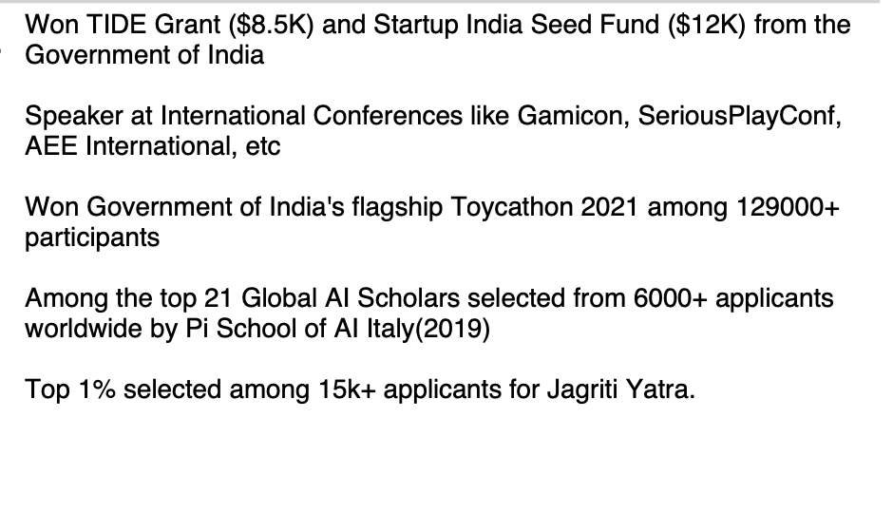

Activity | Role | Details (200 char)
Mentorship | Multiples roles | Through OpenTech, Jagriti Yatra, TreeForest Capital and other engagements, I’m helping 18 entrepreneurs, most of them being college dropouts, pro bono on strategic dilemmas and personal struggles.
KhoKho | Captain and Coach | A sport I start my day with for the past 14 years, where I learned my first leadership lessons and continue to grow physically, mentally and philosophically.
Board Game Facilitator | Volunteer at Vipo and SDMC board game communities | Twice a month, I facilitate power yet fun board games spreading happiness and helping strangers bond as they take away a learning or two after every game.

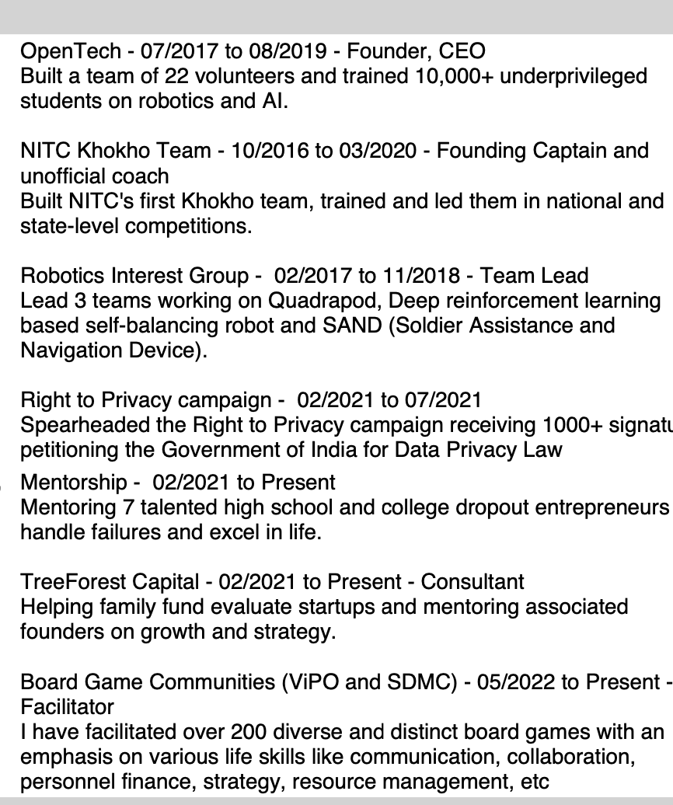

Send test score?
Grade for courseworks?
Growing up in a small town in the Western Ghats, I witnessed how limited access to education, technology, and resources held back talented individuals. While I leveraged online networking to nurture 20000+ LinkedIn connections and broaden my horizons, many of my peers couldn't pursue their dreams. These experiences shaped my resolve to empower others. During Jagriti Yatra, I mentored rural entrepreneurs grappling with outdated practices and limited guidance. This journey demonstrated how leadership can align purpose with action, break systemic barriers, and drive meaningful progress.

This realization evolved into my long term vision of empowering businesses to become catalysts for societal change. I aim to achieve this by establishing PeopleGamez in the United States as a global leader in strategy consulting, helping organizations align purpose with growth and societal impact.

I laid groundwork for my vision by founding PeopleGamez, a strategy consulting firm that helps purpose-driven organizations craft growth strategies in market positioning, operational efficiency, and customer loyalty. Early on, our simulations lacked the depth executives expected, leading to bankruptcy. Forced to lay off my team, I upskilled myself by operating from a boardgame cafe, working pro bono with thought leaders. These experiences honed my skills in product-led and organic growth strategies while teaching me stakeholder management and the ability to foster collaboration under pressure. By facilitating workflow optimizations, cross-functional collaboration, and data-driven growth discovery, our evolved simulations helped five ventures across three countries survive.

Despite these strides, scaling PeopleGamez internationally revealed critical skill gaps. My domain knowledge remains limited to strategic realignments and launching new initiatives, leaving me underprepared for advanced areas like corporate diversification and crisis management. Expanding globally exposed gaps in geographical knowledge, such as navigating regulatory frameworks and cultural nuances. Without enterprise credibility, stemming from limited experience with large-scale projects, my clients hesitate to extend engagements. Finally, as a self-taught CFO, my financial acumen is constrained, resulting in cash-flow mismanagement.

Addressing these gaps requires structured growth through MBA and post-MBA roles. Post-MBA, I plan to join AlixPartners or Strategy& as a strategy consultant and gain exposure to large-scale implementation challenges, cross-cultural team management, and navigating global markets, building the foundation before returning to scale impact through PeopleGamez.

I have already been benefitting from Wharton resources. Insights from Wharton Interactive have shaped PeopleGamez, inspiring me to drive leadership strategies leveraging simulations. Further, through my MBA, Christopher's Accounting for Entrepreneurs elective will enhance my financial analysis skills for better cash-flow management. Sarah Hammer's Global Business Week and Global Modular Courses in Rwanda will hone my global leadership skills. Advanced Global Strategy will deepen my ability to balance local responsiveness with global efficiency, while Venture Fellowship will refine my crisis management skills through hands-on military and firefighting simulations.

Wharton's P3 commitment to equitable outcomes aligns with my vision of nurturing principled leaders at PeopleGamez. Mentorship from Jeff Klein at the Center for Leadership and Change Management will shape my understanding of modern leadership strategies, preparing me to build adaptive leadership ecosystems that empower organizations to make lasting societal impacts.

In 2016, my 68-year-old grandmother collapsed from exhaustion while returning from the only water pump, 8 miles away. Being the only techie in our remote village, I felt responsible and implemented an IoT-enabled irrigation system. Later, my grandfather, emphasizing similar problems faced by villagers, suggested I teach village children to use technology, shifting my perspective from problem-solving to empowering others.

Witnessing the children gain confidence as they developed IoT projects inspired me to launch OpenTech, workshops empowering tribal and slum students to harness technology, solve local challenges, and dream without limitations.

However, I faced challenges;
Colleagues hesitated to volunteer due to academic pressures.
Students skipped workshops to support their families by working weekends.
When my parents questioned why I persisted, I replied: If I cannot break these barriers, how can I inspire others to?

By providing autonomy and linking each volunteer's skills to specific impacts, I ensured everyone felt integral to the mission. Through open appreciation and encouragement, I nurtured my team's intrinsic motivation as they initiated teacher training programs and infrastructure partnerships with NGOs. Dedicating every weekend for three years, we transformed 10,000+ change-seekers into change-makers innovating waterbody cleaning robots and cattle trackers. One student represented India at NASA, and many became entrepreneurs. Today, empowering others and fostering collective impact defines my purpose.

At Wharton, I will further this commitment by:
Inspiring Entrepreneurship through Founders Club:
I plan to organize a series of hands-on workshops that focus on frugal innovation strategies tailored for startups in emerging markets, guiding my peers on validating diverse business metrics and creating impactful ventures.

Imparting Insights on Ecosystem Development:
Through my involvement with the Social Impact Club and OFTW, I will lead discussions on how to leverage community resources effectively and cultivate supportive ecosystems for social programs in developing countries. I will collaborate on projects that address local challenges while providing peers with practical experience in social entrepreneurship.

Empathy-driven Managerial Coaching Workshops through Human Capital Club:
Drawing from my experience in training teachers, facilitating executive workshops, and presenting at international conferences on leadership development, I will organize workshops focussed on developing emotional intelligence and human-centric approaches at Hoover Lounge.

Establishing a Wharton Reverse Mentorship Network:
Inspired by OpenTech's Teach to Learn initiative where students led community workshops, I will initiate student-led workshops for alumni on emerging fields such as Generative-AI and Web3 fostering exchange of perspectives and alumni engagement.

In this section I wish to address my failing grade at Plaksha, my low salary figures and my choice of recommenders.

At Plaksha, I launched Madiee while managing coursework. A personal emergency of my co-founder required me to handle a critical project, leading to a failing grade in 'Persuasive-Presence-3' due to low attendance. I kindly request the admissions team to consider that I was the class topper in Persuasive Presence 1 (CL 002) and Persuasive Presence 2 (CL 006), both with a 4.0/4.0 GPA, as evidence of my academic readiness.

At PeopleGamez and Madiee, I reinvested profits to build assets and only took director remuneration in emergencies, which is why my application lists near zero and zero salary.

In my current organization, as founder and CEO, I do not have direct supervisors. Hence, I am submitting recommendations from my mentor and advisor, Rishi, and my client, Solomon.

